Module 6. Working with inheritance

Inheritance with classes

Need to inherit classes

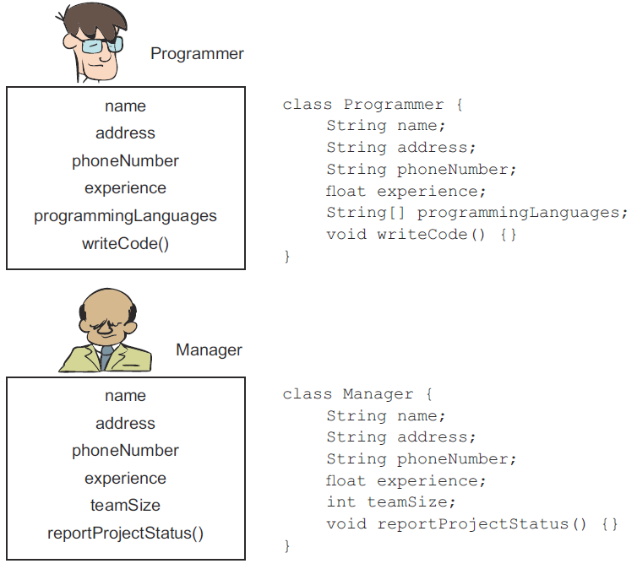

Figure. Properties and behavior of a Programmer and a Manager, together with their representations as classes

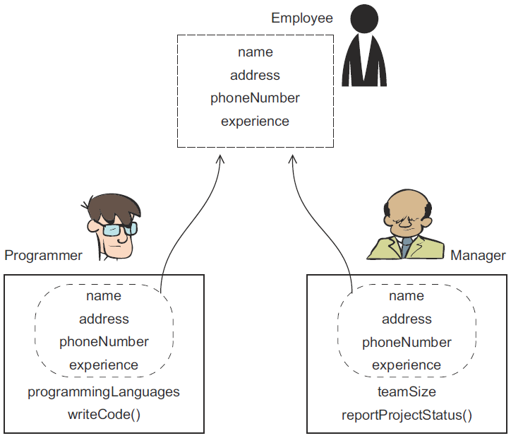

Figure. Identify common properties and behaviors of a Programmer and a Manager, pull them out into a new position, and name it Employee

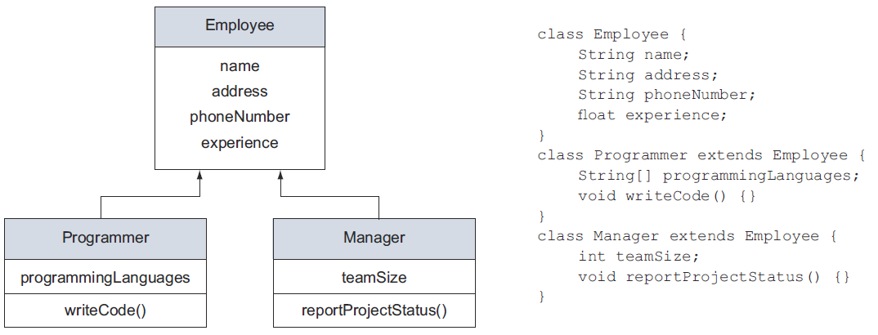

Figure. The classes Programmer and Manager extend the class Employee

EXTENSIBILITY

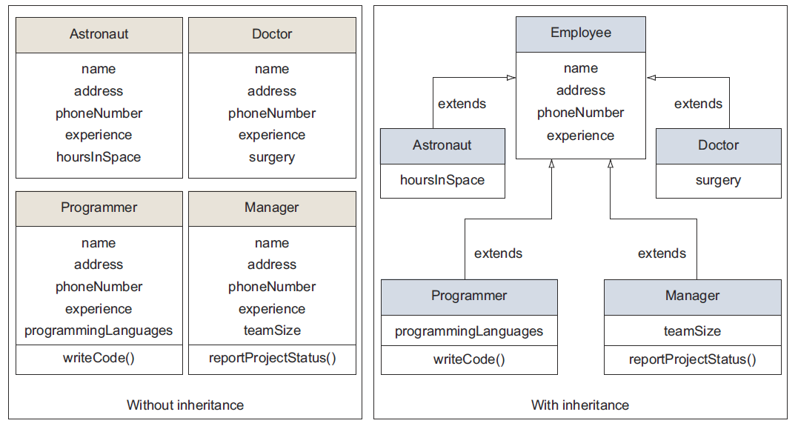

Figure. Differences in the size of the classes Astronaut, Doctor, Programmer, and Manager, both with and without inheriting from the class Employee

TERMS AND DEFINITIONS TO REMEMBER

■ Base class—A class inherited by another class. The class Employee is a base class for the classes Programmer and Manager in the previous examples.
■ Superclass—A base class is also known as a superclass.
■ Parent class—A base class is also known as a parent class.
■ Derived class—A class that inherits from another class. The classes Programmer and Manager are derived classes in the previous example.
■ Subclass—A derived class is also known as a subclass.
■ Extended class—A derived class is also known as an extended class.
■ Child class—A derived class is also known as a child class.
■ IS-A relationship—A relationship shared by base and derived classes. In the previous examples, a Programmer IS-A Person. A Manager IS-A Person. Because a derived class represents a specialized type of a base class, a derived IS-A class is a kind of base class.
■ extends—The keyword used by a class to inherit another class and by an interface to inherit another interface.
■ implements—The keyword used by a class to implement an interface.

Use interfaces

POINTS TO NOTE ABOUT CLASS AND INTERFACE INHERITANCE:
■ A class can inherit zero or one class.
■ A class uses the keyword extends to inherit a class.
■ A class can implement multiple interfaces.
■ A class uses the keyword implements to implement an interface.
■ An interface can’t implement any class.
■ An interface can inherit zero or more interfaces.
■ An interface uses the keyword extends to inherit interfaces.
■ An abstract class can extend a concrete class and vice versa.
■ An abstract class can implement interfaces.
■ An abstract class can extend another abstract class.
■ The first concrete class in the hierarchy must supply actual method implementations
for all abstract methods.

Review notes

Inheritance with interfaces and classes:

■ A class can inherit the properties and behavior of another class.
■ A class can implement multiple interfaces.
■ An interface can inherit zero or more interfaces. An interface cannot inherit a class.
■ Inheritance enables you to use existing code.
■ Inheriting a class is also known as subclassing.
■ A class that inherits another class is called a derived class or subclass.
■ A class that is inherited is called a parent or base class.
■ Private members of a base class cannot be inherited in the derived class.
■ A derived class can only inherit members with the default access modifier if both the base class and the derived class are in the same package.
■ A class uses the keyword extends to inherit a class.
■ An interface uses the keyword extends to inherit another interface.
■ A class uses the keyword implements to implement an interface.
■ A class can implement multiple interfaces but can inherit only one class.
■ An interface can extend multiple interfaces.
■ The method signatures of a method defined in an interface and in the class that implements the interface must match; otherwise, the class won’t compile.
■ An abstract class can inherit a concrete class, and a concrete class can inherit an abstract class.

Reference variable and object types:
■ With inheritance, you can also refer to an object of a derived class using a variable of a base class or interface.
■ An object of a base class can’t be referred to using a reference variable of its derived class.
■ When an object is referred to by a reference variable of a base class, the reference variable can only access the variables and members that are defined in the base class.
■ When an object is referred to by a reference variable of an interface implemented by a class, the reference variable can access only the variables and methods defined in the interface.
■ You may need to access an object of a derived class using a reference variable of the base class to group and use all the classes with common parent classes or interfaces.

The need for casting:
■ Casting is the process of forcefully making a variable behave as a variable of another type.
■ If the class Manager extends the class Employee, and a reference variable emp of type Employee is used to refer to an object of the class Manager, ((Manager)emp) will cast the variable emp to Manager.

Using super and this to access objects and constructors:
■ Keywords super and this are object references. These variables are defined and initialized by the JVM for every object in its memory.
■ The this reference always points to an object’s own instance.
■ You can use the keyword this to refer to all methods and variables that are accessible to a class.
■ If a method defines a local variable or method parameter with the same name as an instance variable, the keyword this must be used to access the instance variable in the method.
■ You can call one constructor from another constructor by using the keyword this.
■ super, an object reference, refers to the parent class or the base class of a class.
■ The reference variable super can be used to access a variable or method from the base class if there is a clash of these names. This situation normally occurs when a derived class defines variables and methods with the same names as in the base class.
■ The reference variable super can also be used to refer to the constructors of the base class in a derived class.

Polymorphism with classes:
■ The literal meaning of the word “polymorphism” is “many forms.”
■ In Java, polymorphism comes into the picture when there’s an inheritance relationship between classes, and both the base and derived classes define methods with the same name.
■ The polymorphic methods are also called overridden methods.
■ Overridden methods should define methods with the same name, same argument list, same list of method parameters. The return type of the overriding method can be the same, or a subclass of the return type of the overridden method in the base class, which is also known as covariant return type.
■ Access modifiers for an overriding method can be the same or less restrictive but can’t be more restrictive than the method being overridden.
■ A derived class is said to override a method in the base class if it defines a method with the same name, same parameter list, and same return type as in the derived class.
■ If a method defined in a base class is overloaded in the derived classes, then these two methods (in the base class and the derived class) are not called polymorphic methods.
■ When implementing polymorphism with classes, a method defined in the base class may or may not be abstract.
■ When implementing polymorphism with interfaces, a method defined in the base interface is always abstract.

Sample questions

Q6-1. What is the output of the following code?
class Animal {
void jump() { System.out.println("Animal"); }
}
class Cat extends Animal {
void jump(int a) { System.out.println("Cat"); }
}
class Rabbit extends Animal {
void jump() { System.out.println("Rabbit"); }
}
class Circus {
public static void main(String args[]) {
Animal cat = new Cat();
Rabbit rabbit = new Rabbit();
cat.jump();
rabbit.jump();
}
}
a Animal
Rabbit
b Cat
Rabbit
c Animal
Animal
d None of the above

Q6-2. Given the following code, select the correct statements:
class Flower {
public void fragrance() {System.out.println("Flower"); }
}
class Rose {
public void fragrance() {System.out.println("Rose"); }
}
class Lily {
public void fragrance() {System.out.println("Lily"); }
}
class Bouquet {
public void arrangeFlowers() {
Flower f1 = new Rose();
Flower f2 = new Lily();
f1.fragrance();
}
}
a The output of the code is:
Flower
b The output of the code is:
Rose
c The output of the code is:
Lily
d The code fails to compile.

Q6-3. Examine the following code and select the correct method declaration to be inserted at //INSERT CODE HERE:
interface Movable {
void move();
}
class Person implements Movable {
public void move() { System.out.println("Person move"); }
}
class Vehicle implements Movable {
public void move() { System.out.println("Vehicle move"); }
}
class Test {
// INSERT CODE HERE
movable.move();
}
}
a void walk(Movable movable) {
b void walk(Person movable) {
c void walk(Vehicle movable) {
d void walk() {

Q6-4. Select the correct statements:
a Only an abstract class can be used as a base class to implement polymorphismwith classes.
b Polymorphic methods are also called overridden methods.
c In polymorphism, depending on the exact type of object, the JVM executes the appropriate method at compile time.
d None of the above.

Q6-5. Given the following code, select the correct statements:
class Person {}
class Employee extends Person {}
class Doctor extends Person {}
a The code exhibits polymorphism with classes.
b The code exhibits polymorphism with interfaces.
c The code exhibits polymorphism with classes and interfaces.
d None of the above.

Q6-6. Which of the following statements are true?
a Inheritance enables you to reuse existing code.
b Inheritance saves you from having to modify common code in multiple classes.
c Polymorphism passes special instructions to the compiler so that the code can run on multiple platforms.
d Polymorphic methods cannot throw exceptions.

Q6-7. Given the following code, which of the options are true?
class Satellite {
void orbit() {}
}
class Moon extends Satellite {
void orbit() {}
}
class ArtificialSatellite extends Satellite {
void orbit() {}
}
a The method orbit defined in the classes Satellite, Moon, and Artificial-
Satellite is polymorphic.
b Only the method orbit defined in the classes Satellite and Artificial-
Satellite is polymorphic.
c Only the method orbit defined in the class ArtificialSatellite is polymorphic.
d None of the above.

Q6-8. Examine the following code:
class Programmer {
void print() {
System.out.println("Programmer - Mala Gupta");
}
}
class Author extends Programmer {
void print() {
System.out.println("Author - Mala Gupta");
}
}
class TestEJava {
Programmer a = new Programmer();
// INSERT CODE HERE
a.print();
b.print();
}

Which of the following lines of code can be individually inserted at //INSERT CODE
HERE so that the output of the code is as follows:
Programmer - Mala Gupta
Author - Mala Gupta
a Programmer b = new Programmer();
b Programmer b = new Author();
c Author b = new Author();
d Author b = new Programmer();
e Programmer b = ((Author)new Programmer());
f Author b = ((Author)new Programmer());

Q6-9. Given the following code, which of the options, when applied individually, will make it compile successfully?
Line1> interface Employee {}
Line2> interface Printable extends Employee {
Line3> String print();
Line4> }
Line5> class Programmer {
Line6> String print() { return("Programmer - Mala Gupta"); }
Line7> }
Line8> class Author extends Programmer implements Printable, Employee {
Line9> String print() { return("Author - Mala Gupta"); }
Line10> }
a Modify code on line 2 to: interface Printable{
b Modify code on line 3 to: publicStringprint();
c Define the accessibility of the print methods to public on lines 6 and 9.
d Modify code on line 8 so that it implements only the interface Printable.

Q6-10. What is the output of the following code?
class Base {
String var = "EJava";
void printVar() {
System.out.println(var);
}
}
class Derived extends Base {
String var = "Guru";
void printVar() {
System.out.println(var);
}
}
class QReference {
public static void main(String[] args) {
Base base = new Base();
Base derived = new Derived();
System.out.println(base.var);
System.out.println(derived.var);
base.printVar();
derived.printVar();
}
}

a EJava
EJava
EJava
Guru
b EJava
Guru
EJava
Guru
c EJava
EJava
EJava
EJava
d EJava
Guru
Guru
Guru

